Assignment3

- Get the employee’s first name after replacing ‘o’ with ‘#’.
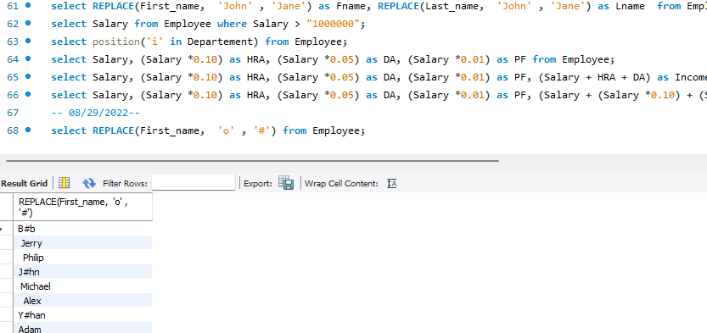
- Get all employees in ascending order by first name and descending order by salary
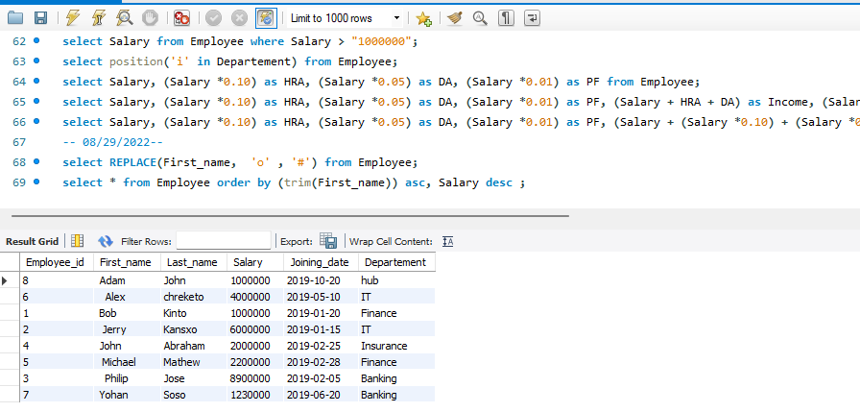
- Get employees whose first name is neither “Jerry” nor “John”.
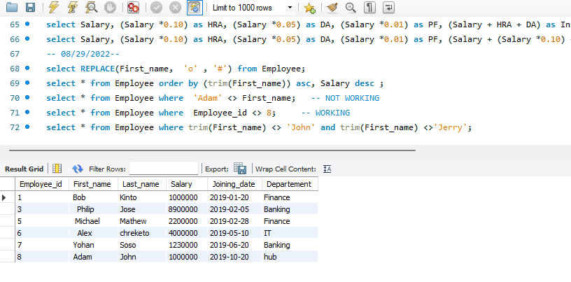

- Get all the details about employees whose first name ends with ‘n’ and contains 4 letters.
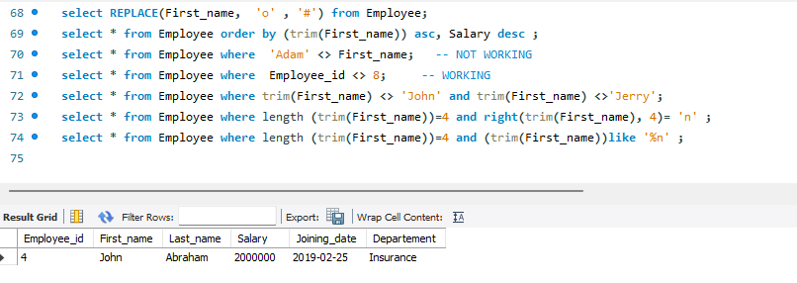
- Get the employee’s department and total salary, grouped by department.
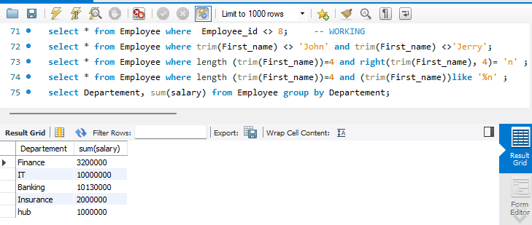
6. Get the department and total salary, grouped by department, and sorted by total salary in
descending order.
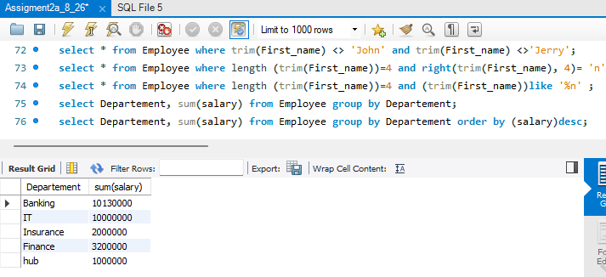

- Get the average salary by department in ascending order of salary.
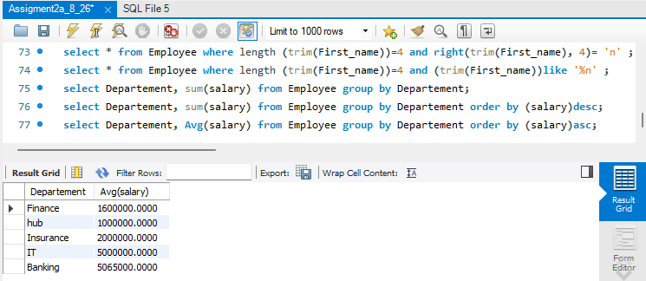
- Get the number of employees grouped by month of joining
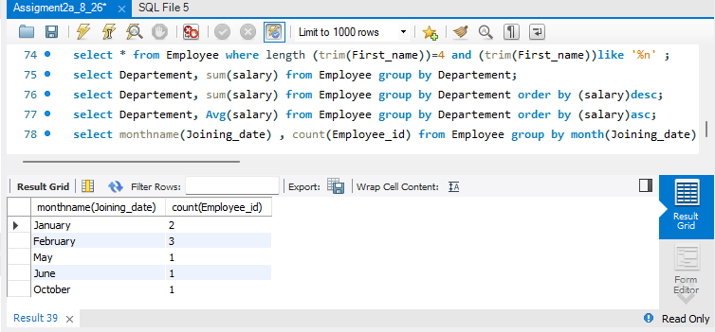
- Get the maximum salary by department in descending order of salary.
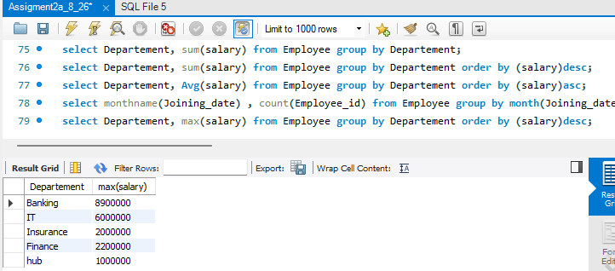

10. Get the department and total salary grouped by the department, where the total salary is greater
than 1,000,000, and sorted in descending order of the total salary.
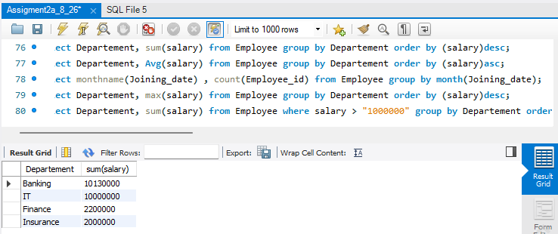
* Find maximum salary for the employees NOT having 'o' in their last name (Try using both
with/without group by)

